Jenkins Projects

1. Jenkins Maven Project :

Note : Jenkins install on Amazon Linux

No maven path setup needed

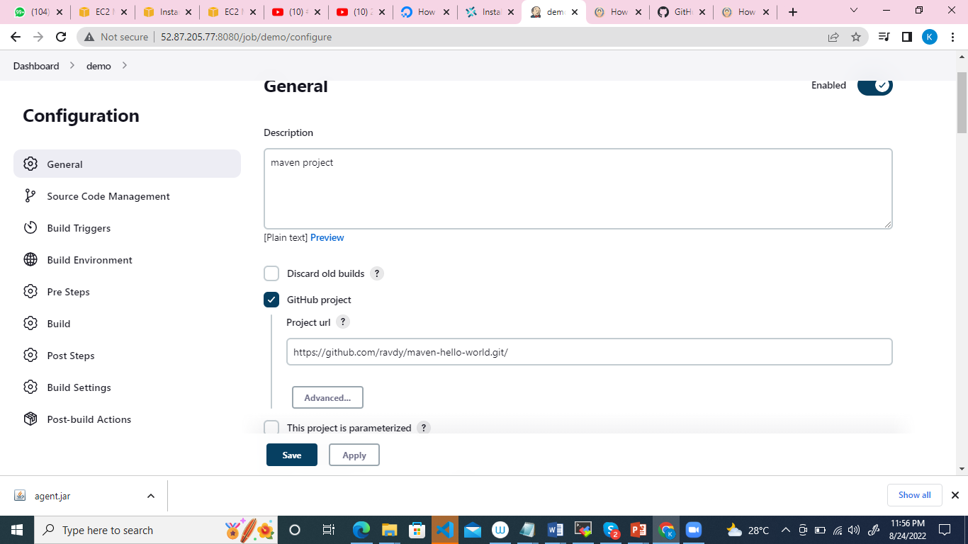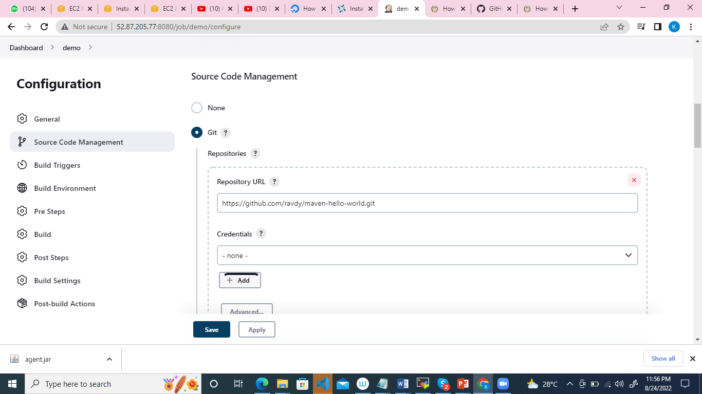

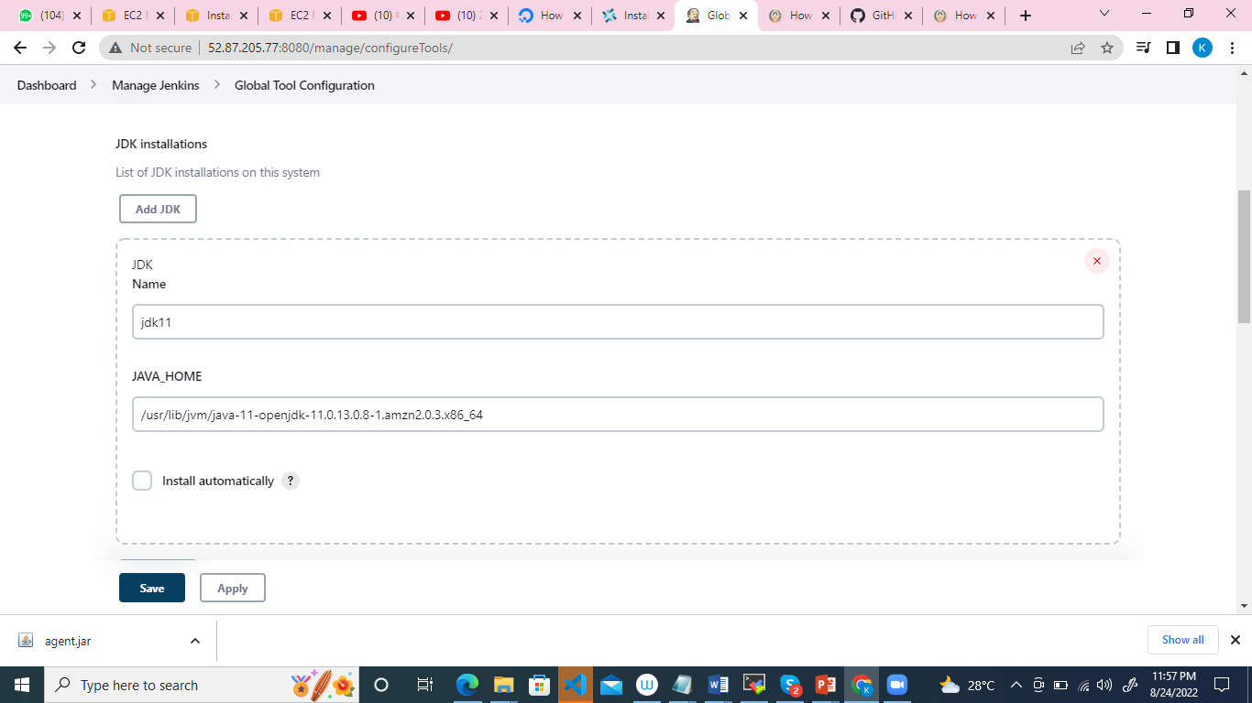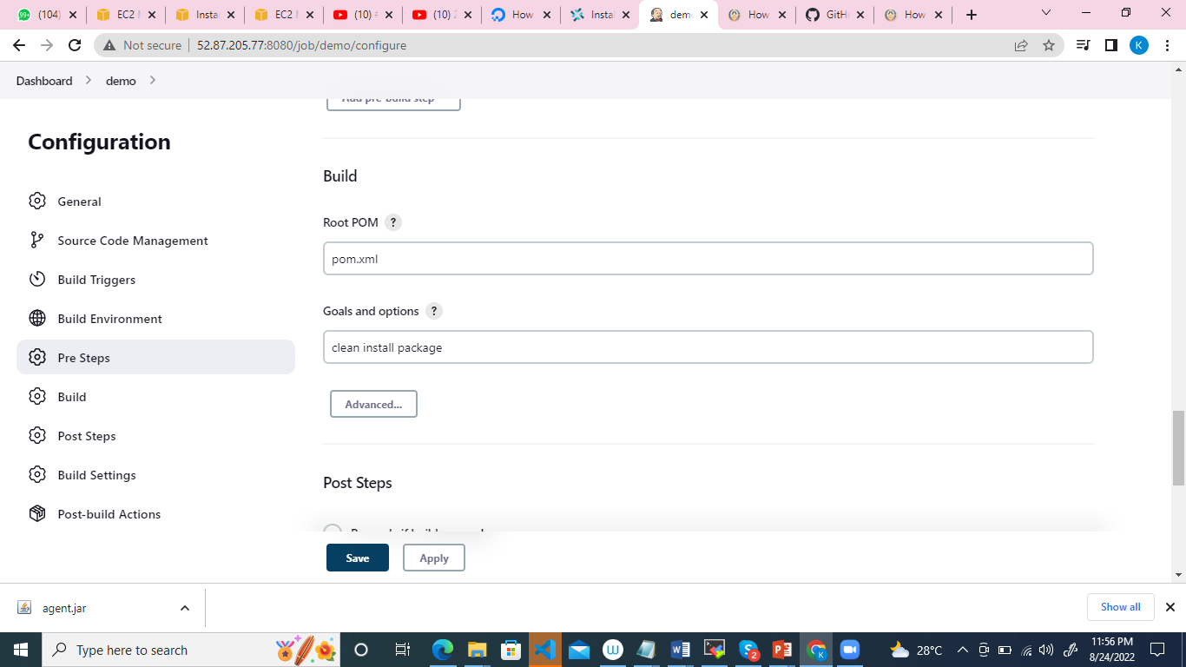

1. Master Slave in Jenkins

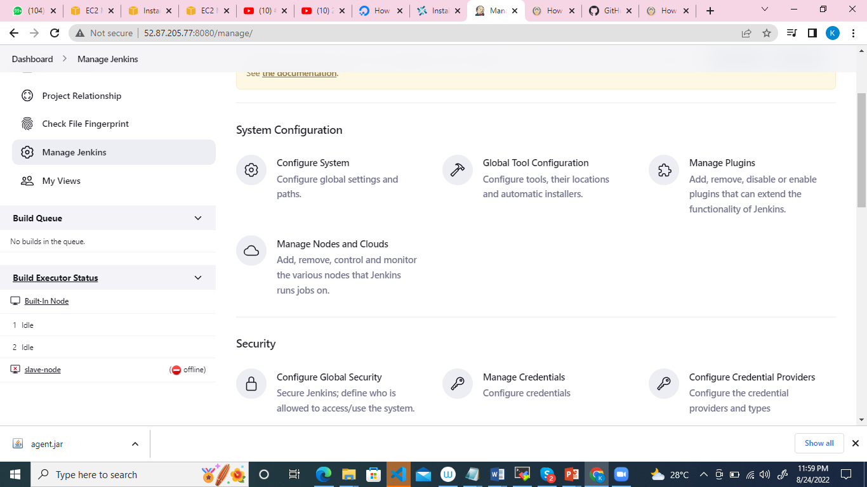

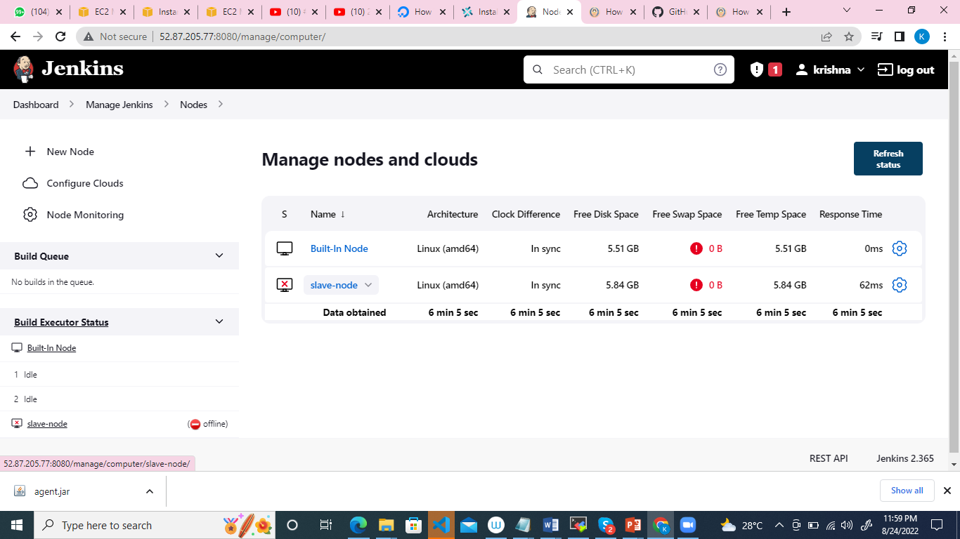

\

<https://www.youtube.com/watch?v=9RsmPNs7gT0&list=PLxzKY3wu0_FLpmifb-i9xw6R-zmWA-7Bc&index=8>